**ACKNOWLEDGEMENT**

I take this opportunity to express my deep sense of gratitude and sincere thanks to all who helped me to complete the work successfully. My first and foremost thanks goes to God Almighty who showered his immense blessings on my effort. I would like to express my sincere gratitude to **Mrs. Amarja Adgaonkar** (Head of the department), for her support and co-operation. I am deeply indebted to my guide, **Prof. Mrs. Shubhangi Verulkar** (Professor, Department of Electronic and Telecommunication Engineering) for her excellent guidance, constant encouragement, suggestions and constructive feedback in the completion of the seminar. I wish to express my sincere gratitude towards the staff members of our Department and Department Library. Finally I thank my parents, all my friends, near and dear ones who directly and indirectly contributed to the successful completion of this work.

**CONTENTS**

|  |  |  |
| --- | --- | --- |
| **Sr No.** | **Title** | **Page No.** |
|  | List of Figure | 3 |
|  | Abstract | 4 |
| 1 | Introduction | 5 |
| 2 | Literature Survey | 6 |
| 3 | Problem Statement | 7 |
| 4 | Methodology | 8 |
| 4.1 | Block Diagram | 8 |
| 4.2 | Hardware Component | 9 |
| 4.3 | Code | 12 |
| 4.4 | Implementation | 14 |
| 4.5 | Result | 15 |
| 5 | Conclusion & Future Scope | 17 |
| 6 | References | 18 |

**List of Figure**

|  |  |  |
| --- | --- | --- |
| Sr.No | Name of Figure | Page No. |
| 1 | Block Diagram | 10 |
| 2 | NodeMCU | 11 |
| 3 | DTH11 & RainFall Sensor | 12 |
| 4 | LDR sensor | 13 |
| 5 | Implementation | 16 |
| 6 | Result | 17 |

**ABSTRACT**

The Internet of Things (IoT) is a latest concept of relating physical computing devices or any other objects to internet and can communicate with each other. Each object is provided with unique identifiers and the ability to transfer data over internet network without human intervention and machine interaction. The project targets on a simple microcontroller, Arduino UNO with connection to the wireless weather monitoring system, WiFi-WeMos ESP8266 which monitor weather condition using three sensors such as temperature, rain and carbon monoxide sensor. It then displays all data in the Blynk application. The project have been developed by using Arduino UNO Microcontroller, WiFi-WeMos ESP8266, DHT 11 temperature and humidity sensor, rain sensor and LDR sensor. It is suitable for monitoring weather in any place and any time. Now-a-days many weather reporting applications are available which gives us information about climatic changes that are going to take place by which man can be aware of present and 4 future climatic changes. Most of the weather reporting applications extracts the data from accurate weather system. Here we are building our own weather reporting system which would give us information about present temperature, humidity etc. We can setup this in our home and get time to time changes in climate which would help us in planning our daily work easily. Like It would be helpful for a farmer in this agricultural activity by which he can protect his crops climatic changes. It would help in transportation giving information of weather conditions etc

**1. INTRODUCTION**

Weather monitoring is an important aspect in many situations. For example, the weather conditions are need to be monitored in order to maintain the healthy growth in plants. Other than that, it also needed for ensuring the safe environment in city or suburban. The people who want to go to city can easily know the weather on that time and will plan their travel easily. Today, there are some announcement about the weather from radio or television but at a certain time only and not efficient anymore. In modernization world, technology is important for human to facilitate everyday life. Hence, the technology is used in this project to help the people to know the condition of weather at a certain place by only using fingertips. The weather monitoring system can be categorized into wired or wireless system. In wireless communication, the connectivity will be more convenient and user-friendly. Thus, weather monitoring system would not need the responsible person to be presence at the location [1]. Wireless communication also is the transfer of information or data over a distance without the use of wires from the transmitter to the receiver. The distance of transferring data can be short or long. The weather monitoring system will collect all the data and will send to the application known as Blynk. This application can allow the user to know the exact weather every time and every day. The motivation for this project is to make a people easily move from one place to another place. An efficient environmental monitoring system is required to monitor and assess the conditions in case of exceeding the prescribed level of parameters (e.g., humidity, temperature and rainfall). Sensor devices are placed at different locations to collect the data to predict the behaviour of a particular area of interest. Here we introduce a smart weather reporting system over the Internet. Our introduced system allows for weather parameter reporting over the Internet. It allows the people to directly check the weather states online without the need of a weather forecasting agency. System uses temperature, humidity as well as rain with humidity sensor to monitor weather and provide live reporting of the weather statistics. The system constantly monitors temperature using temperature sensor, humidity using humidity sensor and also for rain. Weather monitoring system deals with detecting and gathering various weather parameters at different locations which can be analysed or used for weather forecasting. The aim of this system is achieved by technologies such as Internet of Things(IOT) and Cloud. The idea of internet of things is to connect a device to the internet and to other required connected devices. Using Internet the information from the IOT device can easily be transferred to the cloud and then from the cloud to the end user.

**2. LITERATURE SURVEY**

|  |  |  |  |  |  |
| --- | --- | --- | --- | --- | --- |
| No. | Author(s) | Year of Publication | Title of Paper | Domain of paper | Findings/Outcomes |
| 1 | R Suresh Babu, T Palaniappan,K Anushya, M Kowsalya , M Krishnadevi | March'19 | IoT Based Weather Monitoring System | Weather Monitoring | By keeping the embedded devices in the environment for monitoring enables self protection (i.e., smart environment) to the environment. |
| 2 | Akash Kumar Jha, Manish Arora, Nikhil Ahlawat | August'22 | Weather monitoring system using IoT | IoT Based Weather Monitoring | This system provides the monitoring access to the temperature, humidity, intensity of light values from anywhere with Internet access. |
| 3 | Mohd Hakimi Bin Zohari, Mohamad Farid Bin Johari | November'20 | Weather Monitoring System using Blynk Application | Blynk Application Based Weather Monitoring | This project entitles “Weather Monitoring Weather using Blynk” which attempt to monitor the weather at the city and also important for farmer. |
| 4 | J. Mounicaa, G. Janakia | April'22 | Weather Monitoring System using IoT for Smart Farming | Smart Farming | The Aim of the proposed work is to design an automated, fast-processing, real-time weather monitoring system for achieving sustainable development in smart farming against climatic action. |
| 5 | Balakrishnan Sivakumar , Chikkamadaiah Nanjundaswamy | June'21 | Weather monitoring and forecasting system using IoT | IoT Based Weather Monitoring | By deploying sensor devices in the environment, it will record real time data. It can cooperate with other objects through the network. Then the collected data and analysis results will be available to the end user through the Wi-Fi. The smart way to monitor environment and an efficient, low-cost entrenched system is presented with different models in this paper. |
| 6 | N. Deepa, Dr. Sounder. | August'22 | IOT BASED HOME AUTOMATION USING - NODEMCU | Smart Home | It is evident from this project work that an individual control home automation system can be cheaply made from low-cost locally available components and can be used to control multifarious home appliances ranging from the security lamps, the television to the air conditioning system and even the entire house lighting system. |
| 7 | Mubarak K. Kankara, Al Imtiaz, Imran Chowdhury, Md. Khalid Mahbub Khan, and Taslim Ahmed | September'22 | Arduino and NodeMCU based Smart Soil Moisture Balancer with IoT Integration | Smart Irrigation | According to the system, the water releases to the field only when it is required based on the soil moisture level. |
| 8 | Syeda Bushra Shahewaz and Ch. Rajendra Prasad | January'22 | Track Covid-19 outbreak using NODEMCU-ESP8266 | NodeMCU | This project is done to make people of our country, realize that many among us are suffering from this deathly virus which is a life thread |
| 9 | Banda Anusha | September'21 | NodeMCU Based Social Distancing Alarm Cap | NodeMCU | The device employed a NodeMCU and four ultrasonic sensors to detect and measure the distance between a wearer |
| 10 | AnshikaMishra Ayushi GoelSanjoli OmarDr. S. P. Gaikwad Mrs. S. P. Tondare | June'19 | Air Pollution and Noise Pollution Detector Using ESP8266 | ESP8266 | The Internet of Things (IoT) shall be able to incorporate transparently and seamlessly many different and heterogeneous end systems, while providing open access to selected subsets of data for the development |

**3. PROBLEM STATEMENT**

Weather monitoring is also important not just in defining present climate, but also for detecting climate change and providing the data to input into models which enable us to predict future changes in our environment.

Because of the wide variety of uses for the information, there are a large number of environmental variables which are of interest to different groups of people. These include solar radiation, wind speed, wind direction, barometric pressure, air temperature, humidity and net radiation. The demand for these data, usually on an hourly or more frequent timescale, has increasingly been met by the development and widespread deployment of automatic weather stations (AWS’s) over the past 30 years or so.

The existing weather monitoring systems generally use weather stations that use multiple instruments such as thermometers, barometers, wind vanes, rain gauge etc. to measure weather and climate changes. Most of these instruments use simple analog technology which is later physically recorded and stored in a data base. Existing weather monitoring systems that are used in the field generally consist of unconventional and heavy machinery that consists of numerous moving parts that require constant maintenance and need to be manually monitored and changed frequently. Power requirements are one of many major constraints as these instruments are generally sited far from main power supply. This adds to the cost of using such instruments.

**4. METHODOLOGY**

The methodology for this project contains the flow chart and block diagram, which explains the overall method taken during the project. Besides that, this part also introduces software development and hardware development. In order to develop the system, its starts with designing the system. Designing the system conclude identifying the suitable component. After all the component has been listed, the next step is to build up all component. This part will focus on coding using IDE software.

**4.1 Block Diagram**

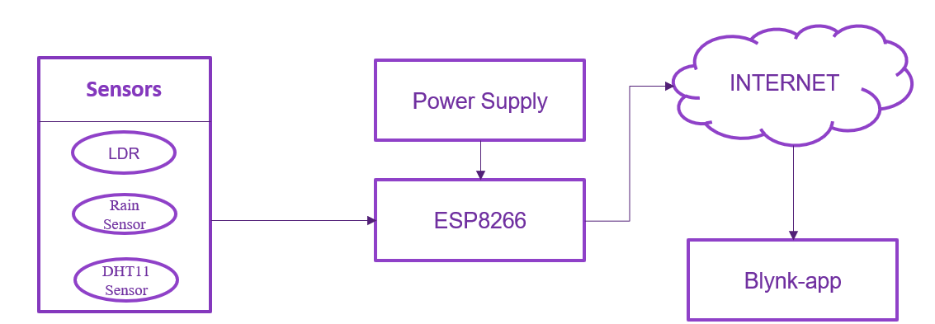

**Figure no 4.1.1: Block diagram of Weather Monitoring System using Blynk**

In IOT enabled weather monitoring system project, NODEMCU measures four weather parameters using three respective sensors. These sensors are temperature sensor, humidity sensor and rain level sensor. These three sensors are directly connected to NODEMCU. NODEMCU has inbuilt Analog to digital converter. Then it sends these parameters to Internet using IOT techniques. The process of sending data to the internet using Wi-Fi is repeated after constant time intervals. The NodeMCU ESP8266 is the main component in the system that is connected to all the components as shown in the Figure 1. All the collected data will be sent to Blynk application.

**4.2 Hardware Components**

* **NodeMCU-ESP8266**

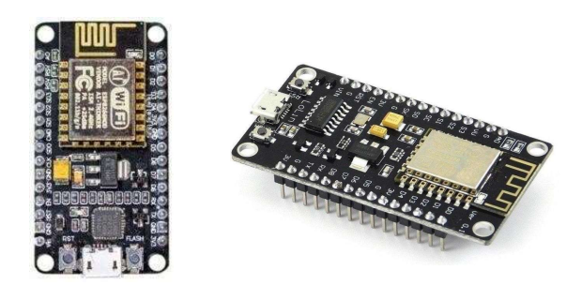

Figure no 4.2.1: NodeMCU – ESP8266

The NodeMCU (Node MicroController Unit) is an open-source software and hardware development environment built around an inexpensive System-on a-Chip (SoC) called the ESP8266. The ESP8266, designed and manufactured by Espress if Systems, contains the crucial elements of a computer: CPU, RAM, networking (WiFi), and even a modern operating system and SDK. That makes it an excellent choice for the Internet of Things (IoT) projects of all kinds. The ESP8266 WiFi Module is a self contained SOC with integrated TCP/IP protocol stack that can give any microcontroller access to your WiFi network. The ESP8266 is capable of either hosting an application or offloading all WiFi networking functions from another application processor. Each ESP8266 module comes pre-programmed with an AT command set firmware, meaning, you can simply hook this up to your Arduino device and get about as much WiFi-ability as a WiFi Shield offers (and that's just out of the box)! The ESP8266 module is an extremely cost effective board with a huge, and ever growing, community.

* **DHT11 Sensor**

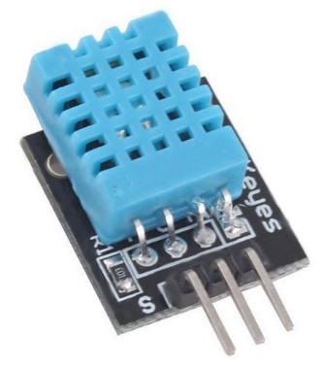

Figure no 4.2.2: DHT11 Sensor

It utilizes a capacitive humidity sensor and a thermistor to gauge the surrounding air, and releases a digital data on the data pin (no analog information pins required). The DHT11 is a commonly used Temperature and humidity sensor. The sensor comes with a dedicated NTC to measure temperature and an 8-bit microcontroller to output the values of temperature and humidity as serial data. The sensor is also factory calibrated and hence easy to interface with other microcontrollers. The main genuine drawback of this sensor is you can just get new information from it once every 2 seconds, so when utilizing our library, sensor readings can be up to 2 seconds old. It works on 3 to 5V power supply. Good for 20- 80% humidity readings with 5% accuracy and for 0-50°C temperature readings ±2°C accuracy.

* **Rain Sensor**

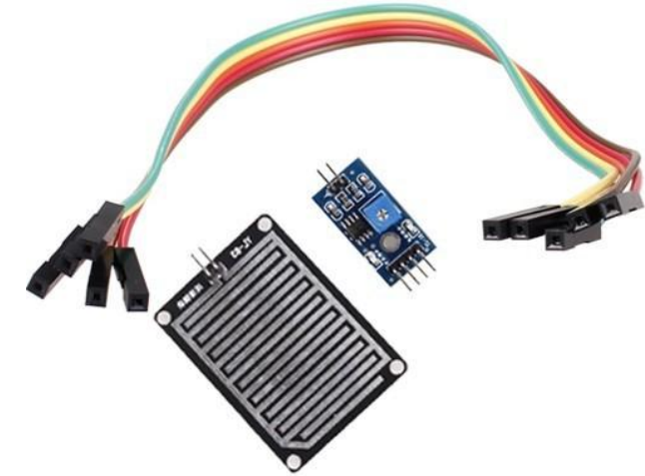

Figure no 4.2.3: DHT11 Sensor

The rain sensor module is an easy tool for rain detection. It can be used as a switch when raindrop falls through the raining board and also for measuring rainfall intensity. The module features, a rain board and the control board that is separate for more convenience, power indicator LED and an adjustable sensitivity though a potentiometer.

* **LDR Sensor**

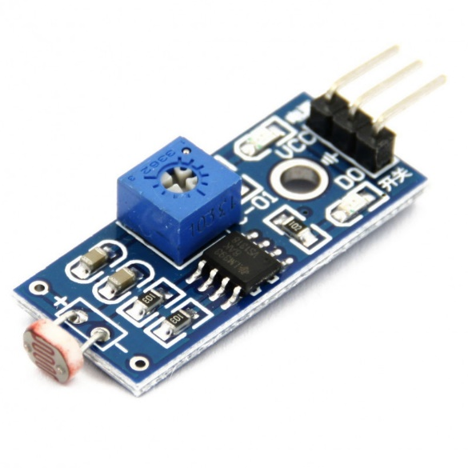

Figure no 4.2.4: Rainfall Sensor

These devices are used where there is a need to sense the presence and absence of light is necessary. These resistors are used as light sensors and the applications of LDR mainly include alarm clocks, street lights, light intensity meters, burglar alarm circuits.

|  |  |  |
| --- | --- | --- |
| **Sr.**  **No.** | **Component** | **Requirement** |
| 1. | NodeMCU-ESP8266 | 1 |
| 2. | DHT11 Sensor | 1 |
| 3. | 3. Rain Sensor | 1 |
| 4. | 4. LDR Sensor | 1 |
| 5. | Breadboard | 1 |
| 6. | Jumper Wires | 10 |

**4.3 Code**

#define BLYNK_TEMPLATE_ID "TMPLswhElqSM"

#define BLYNK_DEVICE_NAME "Quickstart Template"

#define BLYNK_AUTH_TOKEN "4ePCkpFQE2FZhjvu-Ufxb50IJdh0A-4g"

#include <ESP8266WiFi.h>

#include <Blynk.h>

#include <BlynkSimpleEsp8266.h>

char auth[] = BLYNK_AUTH_TOKEN;

// Your WiFi credentials.

// Set password to "" for open networks.

char ssid[] = " ONE";

char pass[] = "1234@1234";

BlynkTimer timer;

BLYNK_WRITE(V0)

{

// Set incoming value from pin V0 to a variable

int value = param.asInt();

// Update state

Blynk.virtualWrite(V1, value);

Serial.print("working at write");

}

// This function is called every time the device is connected to the Blynk.Cloud

BLYNK_CONNECTED()

{

Serial.print("working at connection");

// Change Web Link Button message to "Congratulations!"

Blynk.setProperty(V3, "offImageUrl", "https://static-image.nyc3.cdn.digitaloceanspaces.com/general/fte/congratulations.png");

Blynk.setProperty(V3, "onImageUrl", "https://static-image.nyc3.cdn.digitaloceanspaces.com/general/fte/congratulations_pressed.png");

Blynk.setProperty(V3, "url", "https://docs.blynk.io/en/getting-started/what-do-i-need-to-blynk/how-quickstart-device-was-made");

}

// This function sends Arduino's uptime every second to Virtual Pin 2.

void myTimerEvent()

{

Serial.print("any time");

// You can send any value at any time.

// Please don't send more that 10 values per second.

Blynk.virtualWrite(V2, millis() / 1000);

}

V

oid setup() {

// put your setup code here, to run once:

pinMode(D4,OUTPUT);

Serial.begin(9600);

Blynk.begin(auth," ONE","1234@1234");

while(WiFi.status()!=WL_CONNECTED)

{

Serial.print("..");

delay(200);

}

Serial.println();

Serial.println("connected");

timer.setInterval(1000L, myTimerEvent);

}

void loop() {

Blynk.run();

timer.run();

// put your main code here, to run repeatedly:

}

**4.4 Implementation**

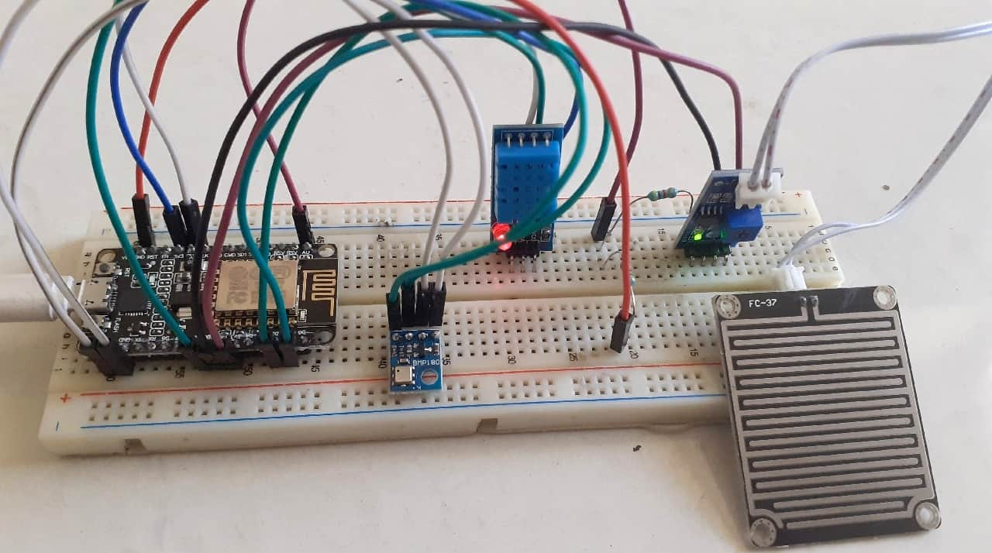

**Figure no 4.4.1 : Implemented hardware on breadboard.**

In modernization world, technology is important for human to facilitate everyday life. Hence, the technology is used in this project to help the people to know the condition of weather at a certain place by only using fingertips. The weather monitoring system can be categorized into wired or wireless system. In wireless communication, the connectivity will be more convenient and user-friendly. Thus, weather monitoring system would not need the responsible person to be presence at the location [1]. Wireless communication also is the transfer of information or data over a distance without the use of wires from the transmitter to the receiver. The weather monitoring system will collect all the data and will send to the application known as Blynk.

**4.5 Result**

**Blynk Application: -**

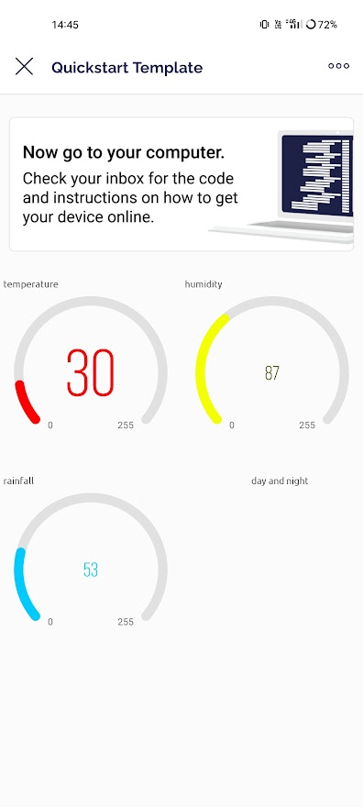

Figure no 4.5.1 :

Here we have been connected to internet and we have reading in two of the sensors as we can see humidity and temperature sensor taking the reading 30 degree , 87 and 53% of water on the rainfall sensor respectively

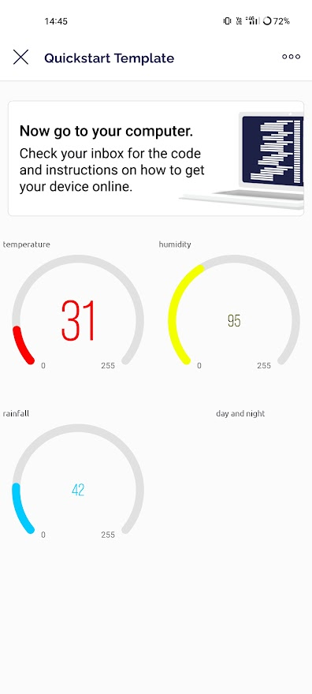

Figure no 4.5.2:

Here we make such condition for DHT11 sensor to make the sensor reading high

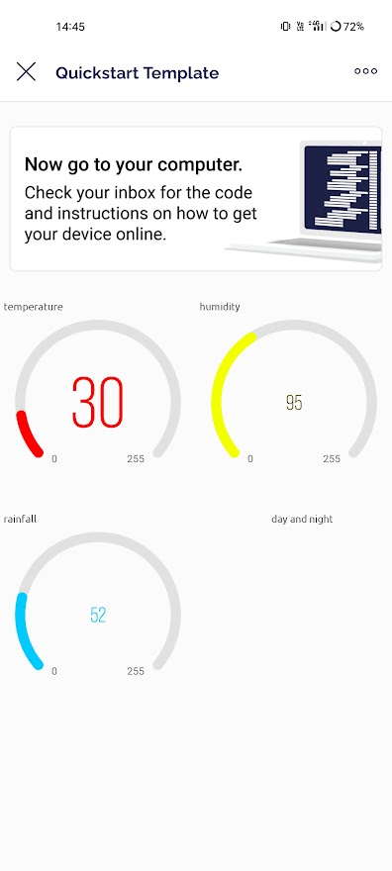

Figure no 4.5.3 :

Here the sensor get back to its normal home temperature

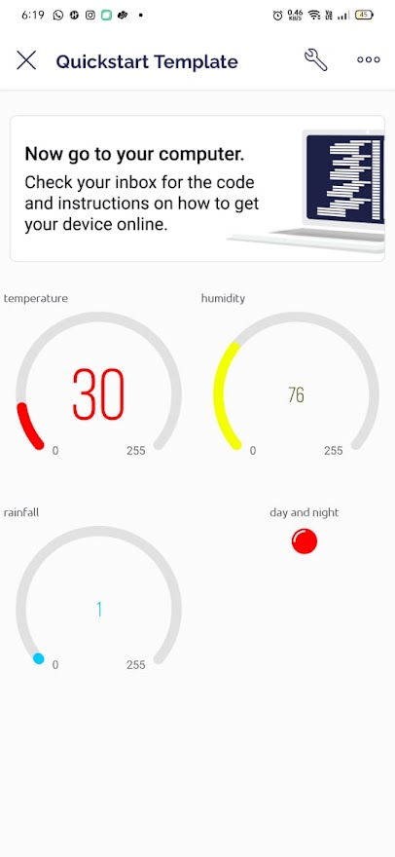

Figure no 4.5.4:

Here our 3rd LDR sensor get to work to show weather is dark or bright.

**5. CONCLUSION & FUTURE SCOPE**

Here we learnt that how present system is better and also more efficient than the other systems. It is exceptionally compatible. It reduces human efforts. This terminate that present project work is a huge success and will provide a considerable way for saving weather parameters of real time and will help farmers, industries, normal people as well as others whose daily life is related with weather and its parameters. It can be used to get required information about for each or particular area for many years. The collected information will used to determine the best conditions required for plants to grow if we talk about agriculture and the farmer can modify the environment conditions which is more suitable for the plan growth. This, will have a large effect on agriculture and also on farmers everywhere. This system will help in monitoring the condition of particular area and help individuals to work accordingly. Suppose a farmer want to grow a crop or tree which grows only in particular type of conditions. So, by this system he can see the temperature and humidity or wind direction as well as other parameters from any place. He will install this system only once and further work will be done automatically. Present model can be updated to monitor the cities and industries for pollution related data gathering. To shield the public health from pollution, model will provide an efficient and very cheaper solution for constant monitoring of environment and its conditions. We can do lots of additions in this system such as adding pressure sensor, gas sensor like CO, soil and moisture retrieving sensor which will able to tell us water content present in soil etc., Other sensors like soil moisture sensor, gas sensor, pressure measuring sensor can also be interfaced with existing system to get data about a particular place.

**6. References**

[1] E. Welbourne, L. Battle, G. Cole, K. Gould, K. Rector, S. Raymer et al., Building the internet of things using RFID: The RFID experience, IEEE internet comput., vol. 13, no. 3, pp.48- 55, May- Jun. 2009.

[2] Shifeng Fang; Li Da Xu; Yunqiang Zhu; JiaerhengAhati; Huan Pei; Jianwu Yan; Zhihui Liu., An integrated system for regional environmental monitoring and management based on internet of things, IEEE Transactions on Industrial Informatics,vol.10, no. 2,pp.1596-1605, May-Jun. 2014.

[3] J. A. Stankovic, Research directions for the Internet ofThings, IEE Internet ThingsJ., vol. 1, no. 1, pp. 39, Feb. 2014.

[4] Shanzhi Chen, HuiXu, Dake Liu, Bo Hu; Hucheng Wang, IoT: Based Weather Monitoring System, no. 3, July’22.

[5] L. Atzori, A. Iera, and G. Morabito, The internet of things: A survey, Comput. Netw., vol. 54, no. 15, pp. 27872805, 2010.

[6] P. Bellavista, G. Cardone, A. Corradi, and L. Foschini,Convergence of MANET and WSN in IoT urban scenarios,IEEE Sens. J., vol. 13, no. 10, pp. 35583567, Oct. 2013.

[7] Shaifali M. Arora, Mishti Gautam, Automated Weather Monitoring Station Based on IoT for Smart Cities, vol 12, pp. 48, Jan’22.

[8] L P S S K Dayananda, Amarasingam Narmilan, An IoT based Low-cost Weather Monitoring System for Smart Farming, Oct’21.

[9] Balakrishnan Sivakumar, Chikkamadaiah Nanjundaswamy, Weather monitoring and forecasting system using IoT, vol 55, Aug’21.

[10] Andriy Holovatyy, Development of IoT Weather Monitoring System Based on Arduino and ESP8266 Wi-Fi Module, Jan’21.

**Project Implementation Drive Link: -**

<https://drive.google.com/file/d/1FRHRF3qm9CwcDQ23DRO1IOBTLffbwk3Y/view?usp=drivesdk>